Website Project Proposal
Supreme
Module: Web development
Module code: WEDE5020
Name: Fezile Ngwenya
Student number: ST10486745

Table of Contents
1. Organisation overview 2
2, Website Goals and Objectives 3
3, Proposed website features and functionality 3
4, Design and User Experience 4
5, Technical Requirements 4
6, Timeline and Milestone 5
7, Budget 5
8, Reference 5

1. Organisation overview
- Name: Supreme
(Elbæk, 2024) surmises that the story of Supreme is a tale woven into the fabric of urban fashion and cultural influence. Since its modest beginnings in 1994, Supreme has emerged as an iconic streetwear brand, transcending its roots as a simple skateboard store. Founded by James Jebbia in the vibrant landscape of New York City, Supreme's extensive history is a chronicle of rebellion, exclusivity, collaborations, and an enduring legacy that has left an indelible mark on streetwear culture worldwide.
- Mision and vision
Supreme does not publish a standard business mission statement, but its operational strategy is based on authenticity and exclusivity. The brand's basic principle is "being cool enough to survive," with a distinct identity that prioritises the subculture of skateboarding, art, and music over mass-market appeal (36kr, 2025).
- Target Audience
People that into fashion that are between the ages of 18 and 35 who are drawn to streetwear, hip-hop culture, and contemporary art. Collectors looking for limited-edition goods and foreign clients looking for exclusive brand partnerships make up the secondary audience.

2, Website Goals and Objectives
- Improve brand storytelling by using interesting content to highlight collaborations, new product releases, and local culture.
- Increase engagement with features like social feeds, product reviews, and exclusive member access.
- Achieve under 2 seconds loading time on mobile devices for optimal user experience.

3, Proposed website features and functionality
- dynamic hero section with the display to of popular products, buttons for actions, and the newest collections.
- Filtered browsing by category, size, colour, price range, and collaboration; includes sort options and grid or list view.
- High-resolution image galleries, detailed descriptions, size guides, customer reviews, related product recommendations, and quick purchase options.
- understandable procedure with several payment options, a guest checkout option, and the ability to recover abandoned carts.
- Blog showcasing the background content, artist collaborations, fashion trends, and custom content galleries.

4, Design and User Experience
Site Map
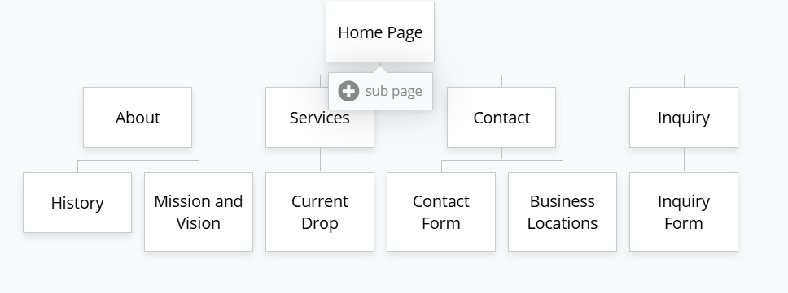

- Design and branding
Colour Scheme: Primary black background with white text; accent colours include Ferrari red (#FF0000) for call-to-action elements. It creates simple and modern aesthetic.
Typography: Futura Bold for headings (reinforcing brand identity), Helvetica for body text (clean and readable). Hierarchy emphasizes product names and limited-edition announcements.
Layout and Design: Minimalist design with generous whitespace; grid-based product layouts and bold imagery with lifestyle photography emphasizing community and culture.
- Mobile-First Approach: Fully responsive design optimized for all devices with touch-friendly navigation and single-column layouts.
- Intuitive Navigation: Persistent header menu, breadcrumb navigation, and logical category structure reducing clicks to desired products.

Wireframe:
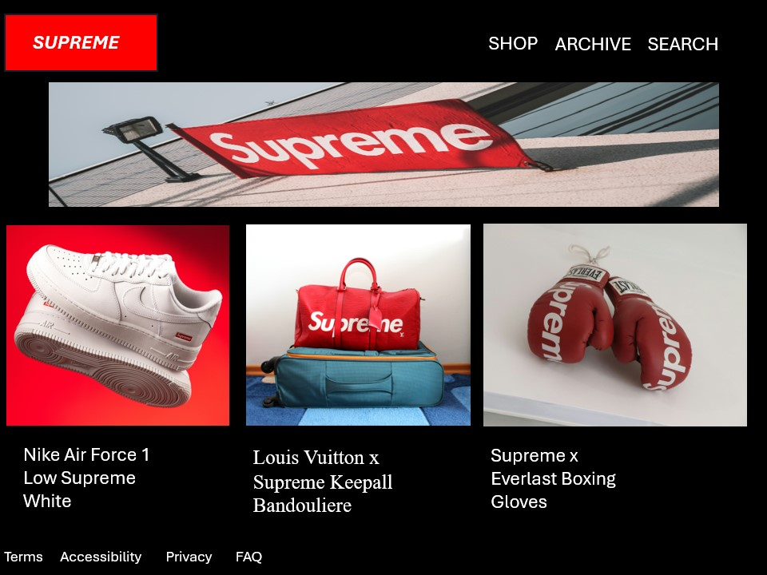

5, Technical Requirements
- Stripe and PayPal for secure transaction processing; PCI DSS compliance for handling credit card information.
- React.js for component-based UI, Vue.js for dynamic product interactions, and Next.js for server-side rendering and improved SEO performance.
- Node.js with Express framework for API development, GraphQL for efficient data querying, and MongoDB for flexible product database management.
- Cloud hosting solution (AWS or Google Cloud) for scalability and reliability. Domain: supreme.com (existing), with CDN implementation for global content delivery.

6, Timeline and Milestone
- Phase 1 (Weeks 1-4): Discovery and Design
Conduct comprehensive user research and competitive analysis. Create diagrams and high-fidelity mockups for each major page.
- Phase 2 (Weeks 5-12): Frontend Development
Create responsive components; construct navigation and product pages; and incorporate design system aspects.
- Phase 3 (Weeks 13-20): Backend and Integration
handle payment processing; and set up database and user authentication systems.
- Phase 4 (Weeks 21-24): Testing and Launch
quality assurance testing will be conducted, performance optimization, security checks, and a staged deployment to the production environment.

7, Budget
Development $15,000 to $25,000
Hosting - $6,000
Maintenance (Security patches and 24/7 uptime monitoring) - 8400 to/month

8, Reference
Elbæk, J. (2024). The history of Supreme. [online] UNMARKET. Available at: https://www.unmarket.eu/blogs/blog/the-history-of-supreme?srsltid=AfmBOoqGh43LLCWRZSydStHYEsTPRNxrvyAqUu-Oz1hQag-hpkChFk0j [Accessed 19 Apr. 2026].

Zhou Jiali (2024) 150亿潮牌要被卖了. Available at: https://36kr.com/p/2796726966301570 (Accessed: 30 March 2026).
Unsplash (2019). Photo by Redd F on Unsplash. [online] unsplash.com. Available at: https://unsplash.com/photos/supreme-flag-c2x94-kmQcQ [Accessed 19 Apr. 2026].

‌ Lazar Gugleta (2019). white and red Supreme X Louis Vuitton duffel bag. [online] Unsplash.com. Available at: https://unsplash.com/photos/white-and-red-supreme-x-louis-vuitton-duffel-bag-HtaxUxO2vbY [Accessed 19 Apr. 2026].

‌ Vlad Ciutacu (2025). Supreme nike air force 1 sneakers on display. [online] Unsplash.com. Available at: https://unsplash.com/photos/supreme-nike-air-force-1-sneakers-on-display-CalzQPjMRD4 [Accessed 19 Apr. 2026].

Burko, Z. (2022). a pair of red boxing gloves. [online] Unsplash.com. Available at: https://unsplash.com/photos/a-pair-of-red-boxing-gloves-yYQwAKTN_34 [Accessed 19 Apr. 2026].
‌

‌

